 | National University  of Computer and Emerging Sciences  Chiniot-Faisalabad Campus  Department of Artificial Intelligence and Data Science | 
Course Code | AI4002
Course Title | Computer Vision – Lab
Lab Task | 3
Due Date | 16 September 2025
Instructions:
- Rename this Word file as LT2_22F-3170
- If found plagiarism, straight zero will be marked against task.
- Submit task on Due Date. No Late Submission will be Tolerated.

Question 1
Write a python code that traverse a grayscale 2D Image. Make a 5x5 Gaussian Average Filter and Convolve with that Image. At the End Original Image with Average Image will be shown side by side.
1 | 1 | 2 | 1 | 1
1 | 2 | 4 | 2 | 1
2 | 4 | 8 | 4 | 2
1 | 2 | 4 | 2 | 1
1 | 1 | 2 | 1 | 1
Hint:

$$Average Filter= \frac{1}{25}$$

Code
import cv2
import numpy as np
import matplotlib.pyplot as plt

img = cv2.imread('img.jpg', cv2.IMREAD_GRAYSCALE)

height, width = img.shape
print(f"Original Image Size: {height}x{width}")

kernel = np.array([
[1, 1, 2, 1, 1],
[1, 2, 4, 2, 1],
[2, 4, 8, 4, 2],
[1, 2, 4, 2, 1],
[1, 1, 2, 1, 1]
], dtype=np.float32)

kernel = kernel / np.sum(kernel)

output = np.zeros_like(img, dtype=np.uint8)

for i in range(2, height - 2):
for j in range(2, width - 2):
region = img[i-2:i+3, j-2:j+3] # 5x5 region
conv_value = np.sum(region * kernel)
output[i, j] = int(conv_value)

plt.figure(figsize=(12, 6))

plt.subplot(1, 2, 1)
plt.title('Original Image')
plt.imshow(img, cmap='gray')
plt.axis('off')

plt.subplot(1, 2, 2)
plt.title('5x5 Gaussian Filtered Image')
plt.imshow(output, cmap='gray')
plt.axis('off')

plt.show()
Screenshot
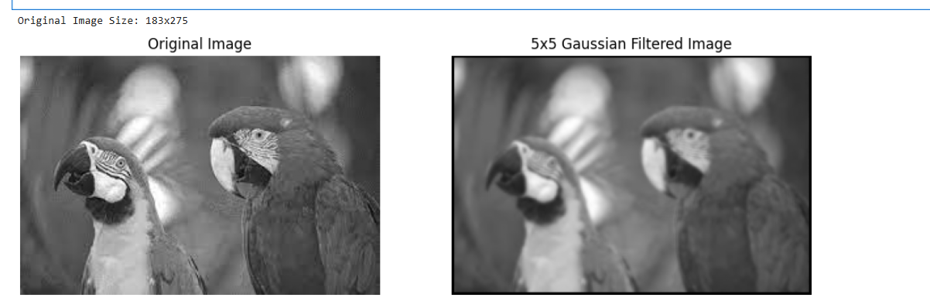

import cv2
import numpy as np
import matplotlib.pyplot as plt

img = cv2.imread('img.png', cv2.IMREAD_GRAYSCALE)

height, width = img.shape
print(f"Original Image Size: {height}x{width}")

kernel = np.array([
[1, 1, 2, 1, 1],
[1, 2, 4, 2, 1],
[2, 4, 8, 4, 2],
[1, 2, 4, 2, 1],
[1, 1, 2, 1, 1]
], dtype=np.float32)

output = np.zeros_like(img, dtype=np.uint8)

for i in range(2, height - 2):
for j in range(2, width - 2):
region = img[i-2:i+3, j-2:j+3]
conv_value = np.sum(region * kernel) / 25.0
output[i, j] = int(conv_value)

plt.figure(figsize=(12, 6))

plt.subplot(1, 2, 1)
plt.title('Original Image')
plt.imshow(img, cmap='gray')
plt.axis('off')

plt.subplot(1, 2, 2)
plt.title('Filtered Image (Sum Divided by 25)')
plt.imshow(output, cmap='gray')
plt.axis('off')

plt.show()

